Code test: runnning commentrary

Installed visual studio 2015()..

Created project

Installed nugget unit test.

Never worked with Json.

Added interfaces under backend

Added reference for webclient.

Built sync for webclient to download code decodejson.cs -> downloadjson.

Built unit test, download works.

Added decode json [JavaScriptSerializer()](https://msdn.microsoft.com/en-us/library/bb302399(v=vs.110).aspx) decodejson.cs -> decodejson.

Added ibook and Ibooks classes just to fix [JavaScriptSerializer()](https://msdn.microsoft.com/en-us/library/bb302399(v=vs.110).aspx) to decode structure of json

Built test.

Added the communications with interface(backend.IbookstoreService.cs) and task.

added async download of task. backend.Class.IbookStoreServices.cs

built frontend MainWindow.cs added and named everything.

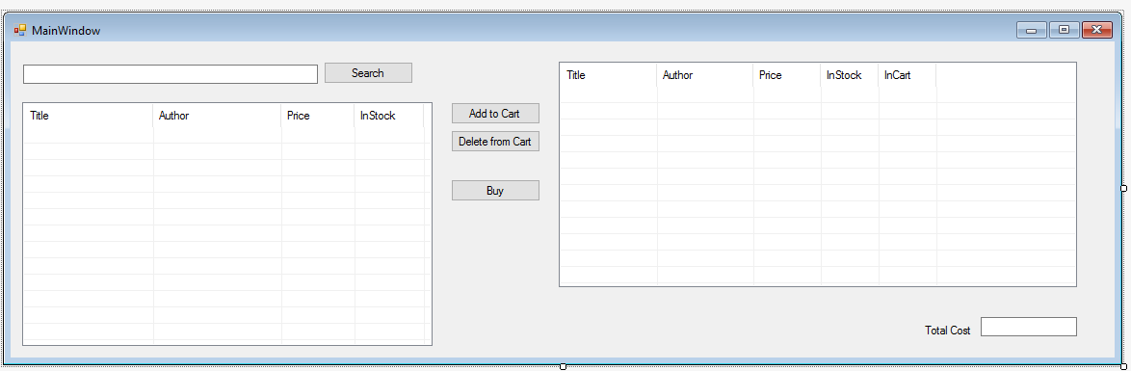

Started with the search button: built the listview interface. Multi select off.

Added the search function to backend.Class.IbookStoreServices.cs

Next “add to cart” button: built the Listview interface.

Select one LVsearch and hit it button and it shows up in LVCART.

Added the totalcost of LVCart.

Added method to Ibookwithinterface for adding subtracting books in cart

Next added “Delete From Cart” button. Select one in LVCART and delete it.

Next added Buy button. Created Notification.cs window

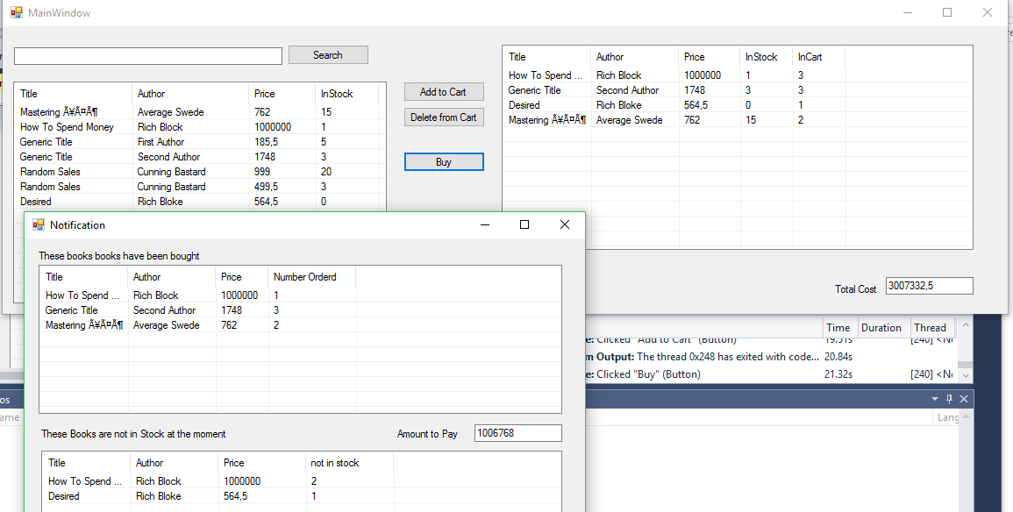

Create shoppingcart.cs and pass object to Notification form on creation

Above picture show how code for notification works it’s all in the loading of the page.

Notes: after MainWindows.cs just wrote the code down.

nothing was mention of in what format codetest was in more than WPF or ASP.Net, etc, etc

said focus on backend so just made two forms.

The total cost is calculated in the forms.(frontend) but info is in backend.

Think in Notification. there are two methods that need to be moved to Shoppingcart.cs. And renamed to better names. They calculate in which listview books are displayed in notification.cs

18 hours of coding: I am a slow coder.

TODO:

Move methods from Notification.cs to static methods in shoppingcart.

TotalCost needs to be moved to backend. And methods created for it.

Create a Class Library. and dump backend into it to create a DLL file, so the frontend can be changed easier.

Fix all the fun spelling errors

Fix all the Private,Public,internal delerations.